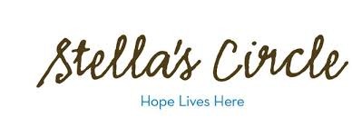
Women’s Leadership Skills Group
Referral Form

Full Name: ________________________ Best method of contact: __ Phone __Text __Email
Date: ________________________ Contact Information: _______________________
DOB: ________________________ Can we leave a message? __ Yes __ No
Self-Referral: __ Yes __ No If ‘No’, please name the referral source: ____________________
Current Address: ___________________________
____________________________
The Women’s Leadership Group is a nine (9) week group that introduces various skills and concepts to help empower women to become leaders within their communities. Successful candidates will be comfortable expressing themselves in a group setting, have a strong understanding of their personal strengths and a willingness to explore ways they can grow personally.
Please list your current and past involvement in organized groups and/or activities. _____________________________________________________________________________
____________________________________________________________________________

Part of this program includes a 14 hour course in Mental Health First Aid. Are you comfortable discussing issues around mental health, possible triggers, resources, etc? ________________

Are there any reasons you may not be able to attend all 3 afternoons per week over the full 9 weeks? _______________________________________________________________

Do you have any mental health or physical health needs that may require additional supports? If yes, please list how we can best support you. _____________________________________
____________________________________________________________________________

What would you like to get out of this group? ______________________________________
___________________________________________________________________________

Signature: ___________________________________
Please send referral to Erin Holland at F: 709.579.7855 or E: e.holland@stellascircle.ca

